z

**Chhatrapati Sambhajinagar, Maharastra - 431001**

**HackVitraSec**



 **+91 9109 3493 92**

**hackvitrasec@gmail.com**

**Be Secure with HVSec - your Security, our Priority**

**Team Work Commitment Letter** - **INTERN**

**To,**  
Niladri Sekhar Maji  
Designation: Web Developer Intern  
Email: niladrimaji9382@gmail.com  
Phone: +91 9382472550

**Subject: Internship** **Commitment Agreement with HackVitraSec**

Dear Niladri Sekhar Maji,

We welcome you to **HackVitraSec** as a valued Intern. This letter confirms your commitment to working with our team during your internship and outlines the expectations and responsibilities involved.

**1. Scope of Internship:**

As an **Intern**, your responsibilities include active participation in cybersecurity projects, research and learning sessions, report writing, internal tasks, and other assignments given by your mentor or team lead.

### ****2. Internship Stipend / Compensation:****

Please note that this internship is **unpaid**.

HackVitraSec **will not be providing any salary, stipend, or monetary compensation** during the internship period. This program is focused on practical learning, skill-building, and real-world exposure in the field of cybersecurity.

**3. Commitment Declaration:**

By signing this letter, you agree to:

* Work sincerely on all assigned tasks during the internship period.
* Follow company guidelines, timelines, and behavior protocols.
* Maintain confidentiality regarding company tools, data, reports, and client-related materials.
* Not share or use internal resources or information outside HackVitraSec.
* Be available for training and learning sessions as scheduled.
* Understand that if your mentor/trainer finds that your work is not being completed on time, or your performance is unsatisfactory, your internship may be terminated immediately.

**Date:** 07 / July / 2025

www.hackvitrasec.com

* 

**HackVitraSec**

### ****4. Confidentiality Clause:****

You agree to treat all information accessed during your internship as **strictly confidential**. Any unauthorized use or sharing of such information may result in immediate termination and further action if required.

### ****5. Duration:****

Your internship is valid from **08 July 2025** to **08 Jan 2026** unless mutually modified or terminated earlier by either party with prior written notice.

### ****6. Voluntary Agreement:****

You confirm that you are joining HackVitraSec as an Intern **voluntarily** and have understood all the terms mentioned above.

We appreciate your enthusiasm and look forward to a productive internship journey with you.

### Intern ****Acknowledgement****

I, **Niladri Sekhar Maji**, have read, understood, and agreed to the terms mentioned above and confirm my commitment as an Intern at HackVitraSec.

**Warm regards,  
For HackVitraSec**  
Signature: …………………………….  
Name: ………………………………..  
Designation: ………………………….  
Date: 07 / July / 2025



Signature: …………………….  
Name: Niladri Sekhar Maji  
Date: ___ / ___ / 2025

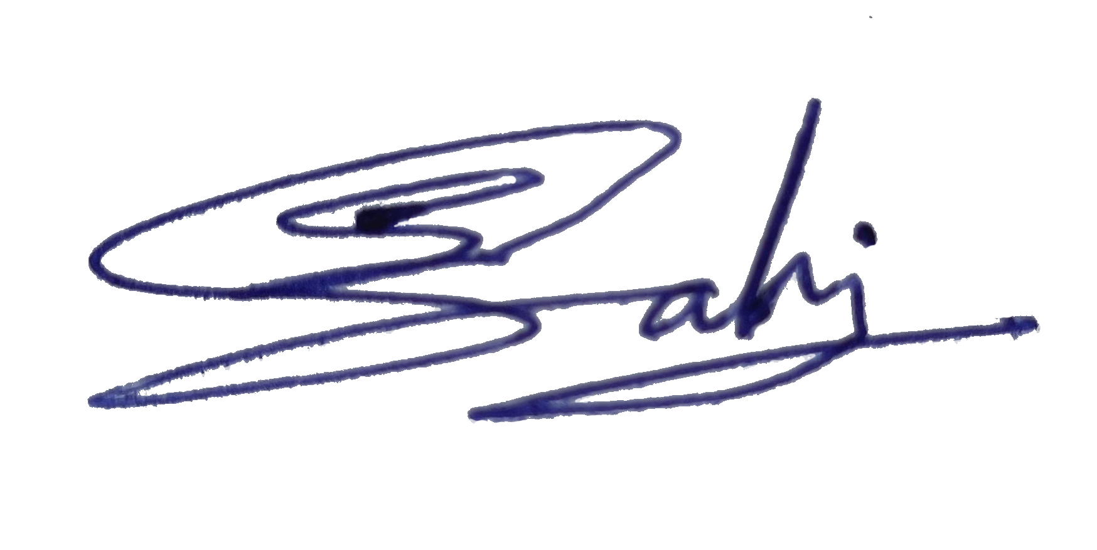

07

08

Shivam Sahu

Founder



www.hackvitrasec.com